- RAM AND STORAGE THEORY

Q1. Create a comparison table listing the main differences between DDR3, DDR4, and DDR5 RAM, including speed, voltage, and typical use cases.
Ans.
Features | DDR3 | DDR4 | DDR5
Release Year | 2007 | 2014 | 2020
Standard speed range | 800–2133 MT/s | 1600–3200 MT/s | 4800–8400+ MT/s
Operating Voltage | 1.5 V (1.35 V for DDR3L) | 1.2 V | 1.1 V
Bandwidth | Lowest | Higher than DDR3 | Highest
Capacity per Module | Typically up to 16 GB | Typically up to 64 GB | Commonly 32–128 GB+
Power Efficiency | Least efficient | More efficient than DDR3 | Most efficient
Error Correction Features | Limited (ECC available on server modules) | ECC available on server modules | On-die ECC built into DDR5 chips (improves reliability)
Physical Compatibility | Not compatible with DDR4/DDR5 slots | Not compatible with DDR3/DDR5 slots | Not compatible with DDR3/DDR4 slots
Typical Use Cases | Older desktops, laptops, legacy servers | Mainstream PCs from mid-2010s to early 2020s, gaming PCs, workstations | Modern gaming PCs, AI workloads, content creation, high-performance desktops, newest servers

- Key Differences at a Glance
- DDR3: Suitable for older systems and basic computing. Lowest speed and highest power consumption of the three.
- DDR4: Offers a strong balance of performance, cost, and compatibility. Still widely used in many desktops and servers.
- DDR5: Provides significantly higher bandwidth, better efficiency, larger capacities, and improved memory architecture, making it ideal for modern high-performance systems.

Q2. Open your laptop or desktop (with power disconnected), locate the RAM slots, and take a clear photo of the installed RAM module. Reinstall the RAM module and verify that your system boots up successfully.<br><br><em><strong>Hint:</strong> Refer to your device manual or a trusted YouTube guide if unsure about RAM removal and installation steps.</em>
Ans. Observation:
- Located the RAM slots and identified the installed RAM module.
- Carefully removed and reinstalled the RAM module by releasing the retaining clips and inserting it back until it clicked into place.
- Powered on the computer after reassembly.
- The system booted successfully, confirming that the RAM was installed correctly.
- Photo to Attach:

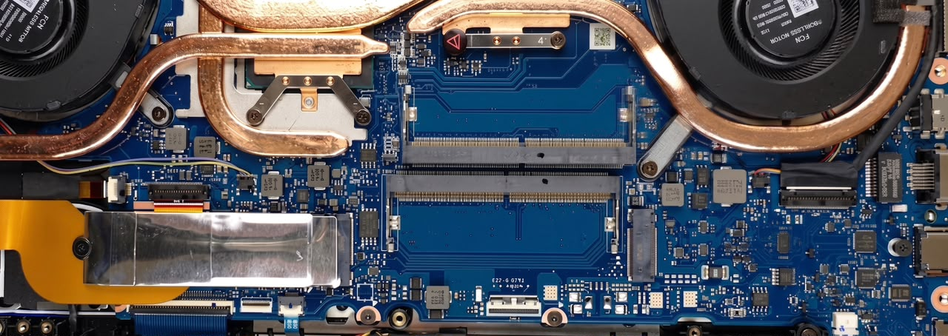

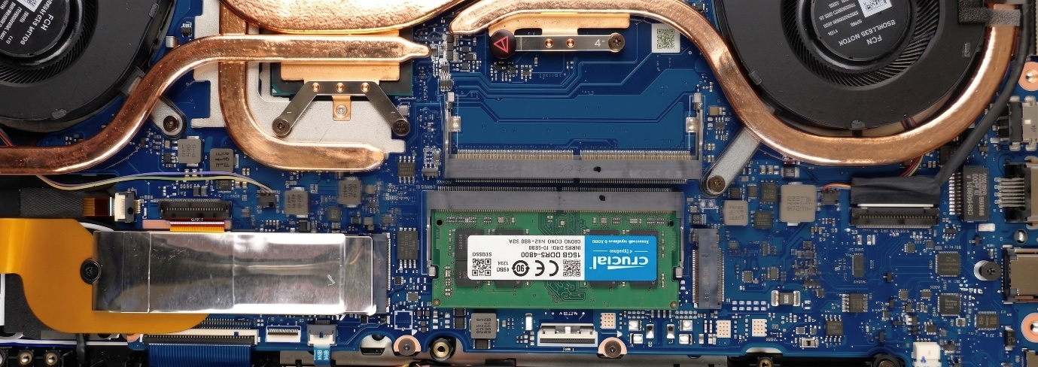

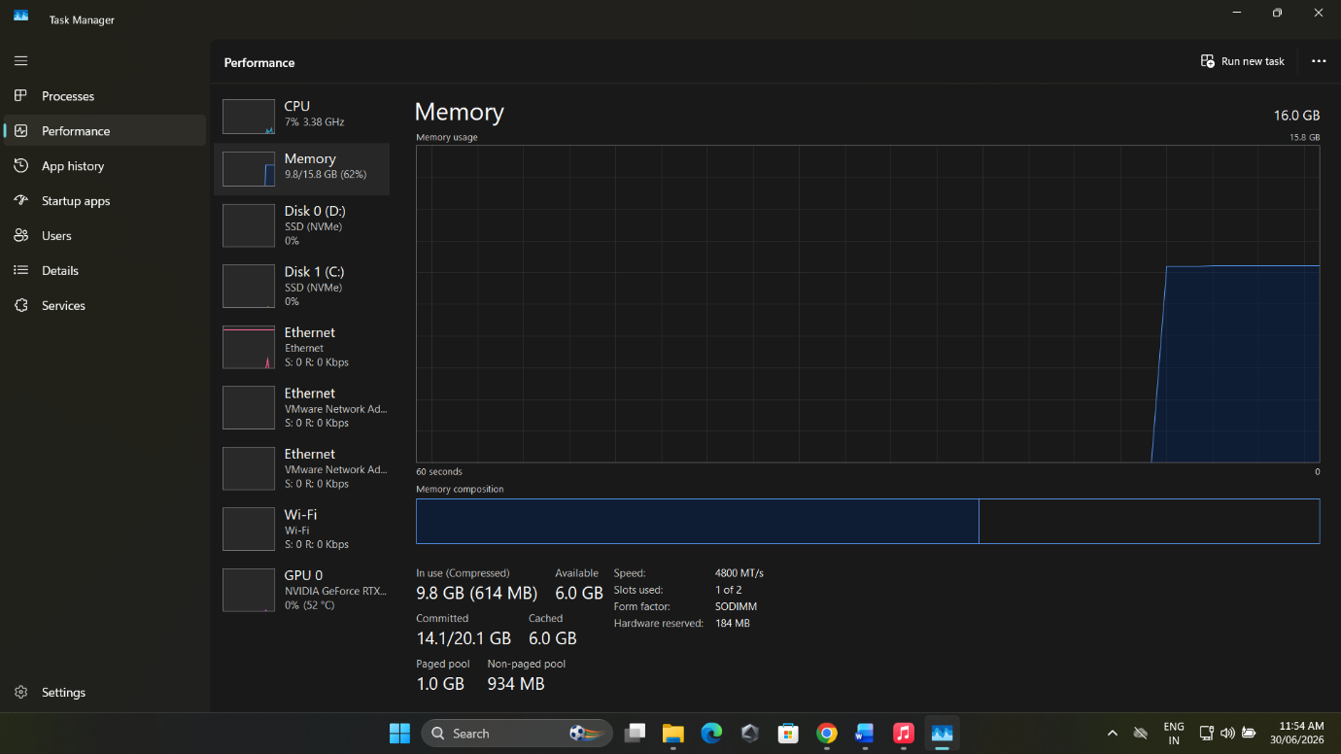

Q3. List three key differences between HDD, SSD, and NVME storage types, and for each, name one app or use case (from apps you use daily) that would benefit most from that storage type.
Ans.
Feature | HDD (Hard Disk Drive) | SSD (SATA Solid State Drive) | NVME SSD (PCIe Solid State Drive)
Speed | Slow (80–160 MB/s) | Fast (500–600 MB/s) | Very Fast (2,000–7,000+ MB/s)
Technology | Uses spinning magnetic disks | Uses flash memory (no moving parts) | Uses flash memory with PCIe interface for maximum speed
Best For | Large, low-cost storage | Everyday computing and faster boot times | Gaming, video editing, and high-performance tasks

- Daily App / Use Case Examples
Storage Type | App/Use Case | Why It Benefits
HDD | Storing movies, photos and music | Provides a lot of storage space at low cost
SSD | Google Chrome | Opens quickly and loads websites faster than an HDD.
NVME SSD | Adobe Premiere Pro (or modern AAA Title Games) | Loads large files and projects much faster, reducing waiting time and improving performance.

Q4. Remove the storage drive (HDD or SSD) from your system, take a photo of the connector type (SATA, M.2, or NVMe), and reinstall the drive. Confirm that your device recognizes the storage after reassembly.<br><br><em><strong>Constraint:</strong> Only perform this task if you have access to a device you are allowed to open. If not, find and share a YouTube video link showing the process for your laptop/PC model.</em>
Ans. I do not have access to a device I am allowed to open so on behalf of that I have provided a YouTube video link showing the process of a ASUS Tuf series laptop RAM and NVME SSD Upgrade.
Video Link - https://youtu.be/HenR_Ac8IfI?si=7AVqSn72hTYhWGwS

